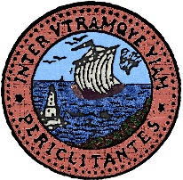
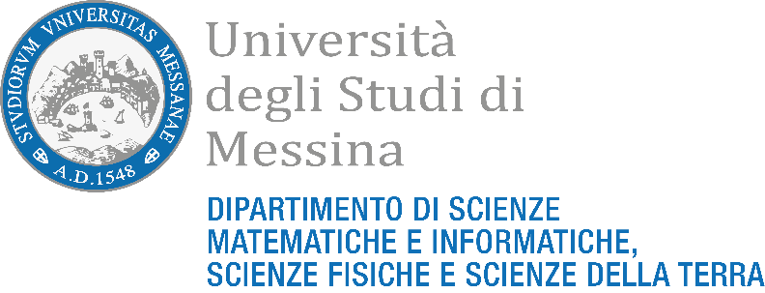
Accademia Peloritana
dei Pericolanti

INTERNATIONAL WORKSHOP ON
ADVANCES AND APPLICATIONS IN GEOFORENSICS:
Unraveling Crimes with Geology
26th September 2022, Messina, Italy

REGISTRATION REQUEST FORM
The registration is free of charge

PLEASE SEND THIS FORM TO E-MAIL

unravelingcrimeswithgeology22@gmail.com

BEFORE 31 July 2022

FULL NAME
First name Last Name

Student Graduate PhD student Dr. Prof. Other

Company:

Company Address:

Mobile:

Email:

Type of participation:

Oral presentation (only invited lecture or speaker)

Poster presentation¹ (exclusively in presence)

Auditor² (no presentation, exclusively in presence)

Title and authors of the extended abstract³:

¹ The scientific committee will inform you if your request of registration for the abstract submission will be accepted or not, in function of the peer review process and limit of 40 abstracts.
² The scientific committee will inform you if your request of registration as auditor will be accepted or not, in function of the hall capacity (48 seats).
³ Please, we ask to specify the last name and first name of each author, the title of the abstract, and the speaker evidenced in bold, as in the following:
Somma, R., Morabito, M., and Rossi, M. (2022). “Geoforensics today”.

